theory of change: A practical Tool
  - Creating a Theory of Change with the Community

This worksheet is based on Theory of Change: A Practical Tool For Action, Results and Learning (Organizational Research Services, 2004), pp. 18-29.

OUTCOME MAP

Create this template on a large wall using half sheets of paper

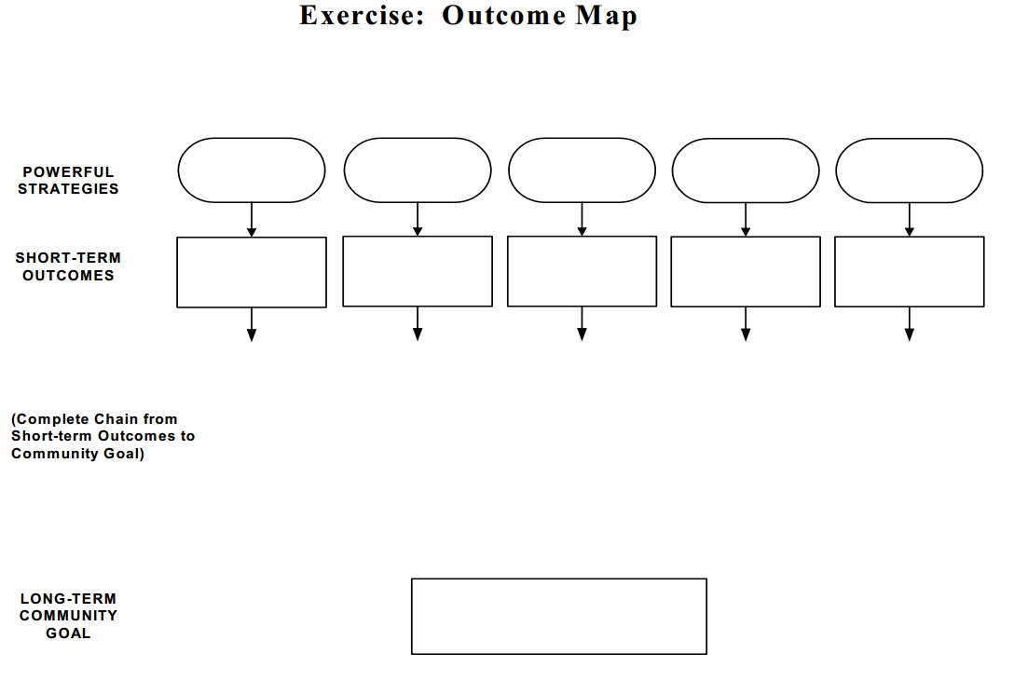

Step 1: Clarify Goals
Identify the ultimate impact you want to achieve in your community. List this in the goal rectangle at the bottom of the chart.

Step 2: Identify powerful strategies
Consider specific strategies or programs that are currently in place which address your ultimate impact. Strategies may include program strategies, campaigns, initiatives, collaborations, public awareness efforts, capacity-building efforts, community mobilization efforts, and so on. List your strategies in the ovals at the top of the chart.

Step 3: Create “so that” chains
Take the first strategy listed and create a “so that” chain, filling in the blank. Repeat until you have linked each strategy to your goal.

“We do X strategy so that __________ results for individuals, families, organizations, or communities.”

Step 4: Link strategies with outcomes and goals
Place the outcomes that form the “so that” chain in rectangles between the strategy and the goal. Draw arrows between these strategies and the connected outcomes and goal. Repeat for each strategy.

Step 5: Test the logic and relevance
Review your completed map and share it with other stakeholders.
- Are there logical linkages between the strategies, outcomes and impacts?
- Are the most relevant outcomes included?
- Are the most relevant strategies included?

Revise, test, revise again.

Step 6: Articulate assumptions
Brainstorm the principles and belief system that underlie the outcome map. Compile these as part of the narrative context for your thinking.

